Plot audio file as time series using Scipy python

Often the most basic step in signal processing of audio files, one would like to visualize an audio sample file as time-series data.

Audio sounds can be thought of as a one-dimensional vector that stores numerical values corresponding to each sample. The time-series plot is a two-dimensional plot of those sample values as a function of time.

[Python’s SciPy library](https://docs.scipy.org/doc/scipy/reference/io.html) comes with a collection of modules for reading from and writing data to a variety of file formats. For example, the scipy.io.wavfile module can be used to read from and write to a ***.wav*** format file.

For the following demonstration, sample audio files [given in this URL](https://www2.cs.uic.edu/~i101/SoundFiles/) are used for the visualization task.

The [read function in the scipy.io.wavefile](https://docs.scipy.org/doc/scipy/reference/generated/scipy.io.wavfile.read.html#scipy.io.wavfile.read) module can be utilized to open the selected*wav* file. It returns the sample rate and the data samples.

>>> from scipy.io.wavfile import read #import the required function from the module

>>> samplerate, data = read('CantinaBand3.wav')

>>> samplerate #echo samplerate

22050

>>> data #echo data -> note that the data is a single dimensional array

array([ 3, 7, 0, ..., -12, -427, -227], dtype=int16)

Compute the duration and the time vector of the audio sample from the sample rate

>>> duration = len(data)/samplerate

>>> time = np.arange(0,duration,1/samplerate) #time vector

Plot the time-series data using ***matplotlib*** package

>>> import matplotlib.pyplot as plt

>>> import numpy as np

>>> plt.plot(time,data)

>>> plt.xlabel('Time [s]')

>>> plt.ylabel('Amplitude')

>>> plt.title('CantinaBand3.wav')

>>> plt.show()

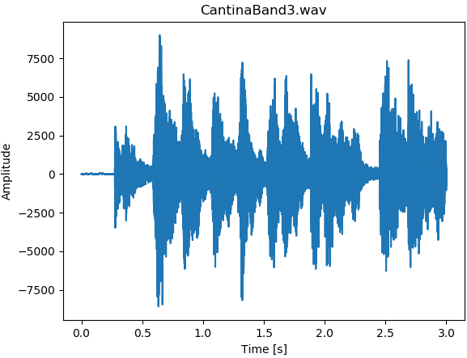Figure 1: Time series plot of audio file using Python Scipy